APQB Unit 2.3 Questions – Unemployment
- The table below shows labor market statistics for a nation.
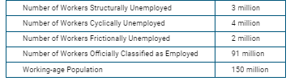
What is the nation’s unemployment rate?
- 4%
- 5%
- 6%
- 9%
- 66.7%
- Which of the following unemployed individuals represents frictional unemployment?
- Marissa, a full-time student who plays on the school’s soccer team.
- Janet, an accounting graduate who is interviewing with a number of accounting firms.
- Sameer, a retired faculty member who volunteers at the local hospital.
- Jeremy, a customer service representative who was laid-off after his job was automated.
- Elizabeth, a financial analyst who was laid off because of the recession.

- The table below shows labor market statistics for a nation.
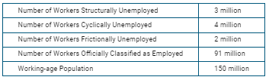
- The natural rate of unemployment is 5 percent.
- The labor force participation rate is 91 percent.
- Discouraged workers are 4 percent of the labor force.
- There are 9 million discouraged workers in the nation
- There are 95 million people in the labor force
- Use the table to answer the question.
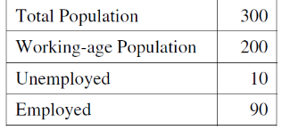
The table above gives population and labor-market data for an economy. The unemployment rate in this economy is
- 3.3%
- 5%
- 10%
- 33.3%
- 50%
- Which of the following is an example of frictional unemployment?
- A former mayor doing volunteer work
- A factory worker who loses her job because of recession
- A college student working part-time at the campus bookstore
- A college graduate interviewing for two available positions
- An architect whose job is replaced by computer software that designs buildings
- Which of the following types of unemployment is caused by a recession?
- Hidden
- Frictional
- Seasonal
- Structural
- Cyclical
- People who have given up looking for jobs are classified as
- cyclically unemployed
- frictionally unemployed
- structurally unemployed
- discouraged workers
- underemployed workers
- An increase in the number of discouraged workers causes the unemployment rate to
- decrease along with the labor-force participation rate
- increase while the labor-force participation rate decreases
- stay the same because the workers are still unemployed
- decrease while the labor-force participation rate stays the same
- increase along with the labor-force participation rate
- Olivia volunteers full time at an animal shelter and will not accept any offers for a paid job for the next six months. Olivia is
- cyclically unemployed
- not in the labor force
- employed
- structurally unemployed
- a seasonal worker
- A nation’s unemployment rate is the ratio of the number of unemployed seeking employment to the nation’s
- labor force
- potential gross domestic product
- number of employed
- working-age population
- total population
- An increase in the number of which of the following will lead to an increase in the unemployment rate?
- Discouraged workers
- Business start-ups
- Self-employed persons
- Persons working 30 instead of 40 hours per week
- Persons quitting part-time jobs to look for full-time ones
- The measured unemployment rate is often criticized for understating the level of joblessness because
- individuals working in the underground economy are counted as employed
- individuals working more than one job are counted more than once
- discouraged workers are counted as unemployed
- discouraged workers are not counted in the labor force
- part-time workers are counted as unemployed
- The following table shows employment data for Country Z 's working-age population.
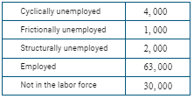
(a) Calculate the unemployment rate for Country Z. Show your work.

(b) Calculate the labor force participation rate for Country Z. Show your work.

(c) Is Country Z currently producing at its potential real output? Explain.

(d) Assuming constant opportunity costs, draw a correctly labeled graph of country Z’s PPC, showing consumer goods on the horizontal axis and capital goods on the vertical axis. Label a point W on the graph that reflects the current level of unemployment.

Answers

13 a) 70K (63K + 4K + 1K + 2K)
b) UR = 7k/63k = 10%
c) No. Cyclical unemployment means the economy is below potential output.
d)
1 | D | 6 | E | 11 | E
2 | B | 7 | D | 12 | D
3 | A | 8 | A | 13
4 | C | 9 | B | 14
5 | D | 10 | A | 15

